Q1) Identify the Data type for the Following:

|  |  |
| --- | --- |
| Activity | Data Type |
| Number of beatings from Wife |  |
| Results of rolling a dice |  |
| Weight of a person |  |
| Weight of Gold |  |
| Distance between two places |  |
| Length of a leaf |  |
| Dog's weight |  |
| Blue Color |  |
| Number of kids |  |
| Number of tickets in Indian railways |  |
| Number of times married |  |
| Gender (Male or Female) |  |

Python Code:

import pandas as pd

# Create dataframe with all Following Data type using Dict

q1 = {'Activity': ['Number of beatings from Wife', 'Results of rolling a dice', 'Weight of a person','Weight of Gold', 'Distance between two places', 'Length of a leaf', "Dog's weight",' Blue Color',  'Number of kids', 'Number of tickets in Indian railways', 'Number of times married', "Gender (Male or Female)"],

'Data Type': ['Discrete', 'Discrete', 'Continuous', 'Continuous', 'Continuous', 'Continuous', 'Continuous', 'Discrete' ,'Discrete' ,'Discrete', 'Discrete', 'Discrete']}

solution1 = pd.DataFrame(q1)

print(solution1)

Output:

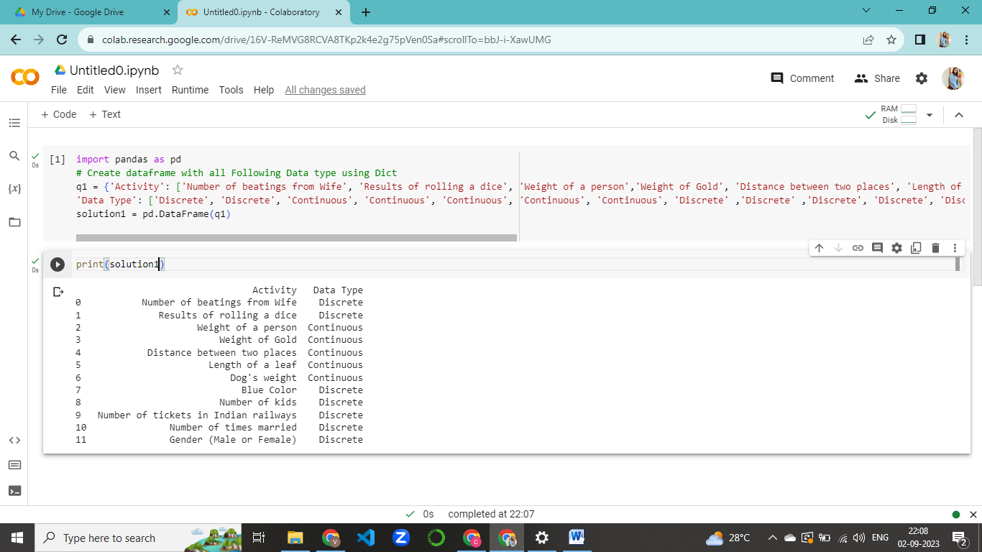

Q2) Identify the Data types, which were among the following

Nominal, Ordinal, Interval, Ratio.

|  |  |
| --- | --- |
| Data | Data Type |
| Gender |  |
| High School Class Ranking |  |
| Celsius Temperature |  |
| Weight |  |
| Hair Color |  |
| Socioeconomic Status |  |
| Fahrenheit Temperature |  |
| Height |  |
| Type of living accommodation |  |
| Level of Agreement |  |
| IQ(Intelligence Scale) |  |
| Sales Figures |  |
| Blood Group |  |
| Time Of Day |  |
| Time on a Clock with Hands |  |
| Number of Children |  |
| Religious Preference |  |
| Barometer Pressure |  |
| SAT Scores |  |
| Years of Education |  |

Python Code-

df={'Data': ['Gender','High School Class Ranking','Celsius Temperature','Weight','Hair Color','Socioeconomic Status','Fahrenheit Temperature','Height','Type of living accommodation','Level of Agreement','IQ(Intelligence Scale)','Sales Figures','Blood Group','Time Of Day','Time on a Clock with Hands','Number of Children','Religious Preference','Barometer Pressure','SAT Scores','Years of Education'],

'Data Type': ['Nominal', 'Ordinal', 'Interval', 'Ratios', 'Nominal', 'Ordinal', 'Interval', 'Ratios', 'Nominal', 'Ordinal' ,'Interval', 'Ratios', 'Nominal', 'Nominal', 'Interval', 'Ratios', 'Nominal', 'Ratios', 'Interval', 'Ratios']}

solution2=pd.DataFrame(df)

|  |
| --- |
|  |

Q3) Three Coins are tossed, find the probability that two heads and one tail are obtained?

Solution

Find the probability of two heads and one tail:  
Three coins are tossed at once.  
The possible toss outcomes will be (HHH, TTT, HTT, THT, TTH, THH, HTH, HHT).  
We have to find the probability of two heads and one tail:  
So, favorable outcomes = THH, HTH, HHT  
Number of favourable outcomes = 3   
Hence required probability is:   
Probability of event to happen P(E) = (Number of favourable outcomes) / (Total Number of outcomes)   
Probability (2H & 1T) = 3/8  
Hence, when 3 coins are tossed. the probability of two heads and one tail is 3/8.

Python Code:

import pandas as pd

toss_outcomes = ['HHH', 'HHT', 'HTH', 'HTT', 'THH', 'THT', 'TTH', 'TTT']

df3 = pd.DataFrame(toss_outcomes, columns=['toss_outcomes'])

# Count the number of outcomes with two heads and one tail

favorable_outcomes = df3[df3['toss_outcomes'].str.count('H') == 2]

Number_of_favorable_outcomes = len(favorable_outcomes)

# Calculate the probabilitty

total_outcomes = len(df3)

probability = Number_of_favorable_outcomes / total_outcomes

print('\nAnswer :')

print("Probability:", probability)

print(f"Probability: {Number_of_favorable_outcomes}/{total_outcomes}")

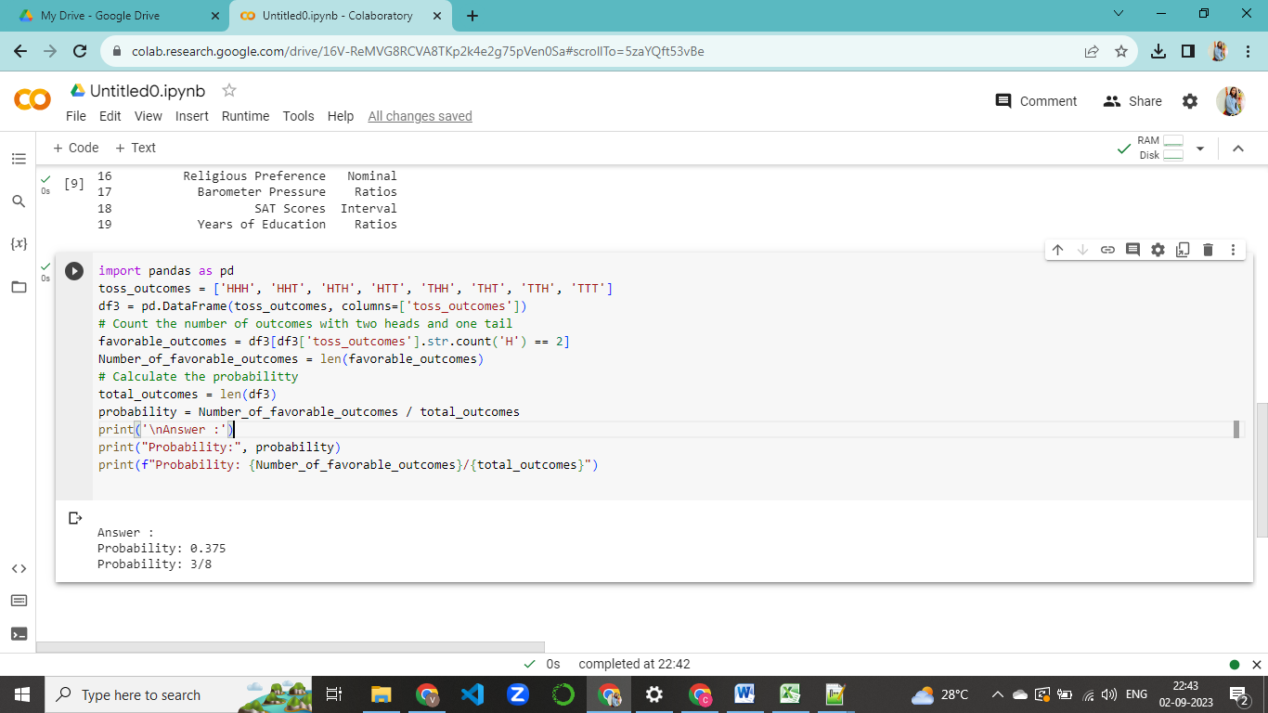

Q4) Two Dice are rolled, find the probability that sum is

1. Equal to 1
2. Less than or equal to 4
3. Sum is divisible by 2 and 3

(a). Equal to 1

Solution

If two dices were rolled, then total possible cases =36

Total Favourable cases (Having sum =1) = 0

As minimum sum is 2 for outcome (1,1).

Hence, probability is 0.

Python Code:

import pandas as pd

outcomes = []  #intialising list

for i in range(1,7):

  for j in range(1,7):

    outcomes.append((i,j))

#print(outcomes)

df4 = pd.DataFrame(outcomes,columns=['Die 1', 'Die 2'])

df4['Sum']=df4['Die 1'] + df4['Die 2']

outcomes_sum_equal_to_1=df4[(df4['Sum']==1)]

num_outcomes_sum_equal_to_1 = len(outcomes_sum_equal_to_1)

total_outcomes = len(df4)

probability = num_outcomes_sum_equal_to_1/ total_outcomes

print('\nAnswer :')

print(f"Probability : {num_outcomes_sum_equal_to_1}/{total_outcomes}")

print("Probability :", probability)

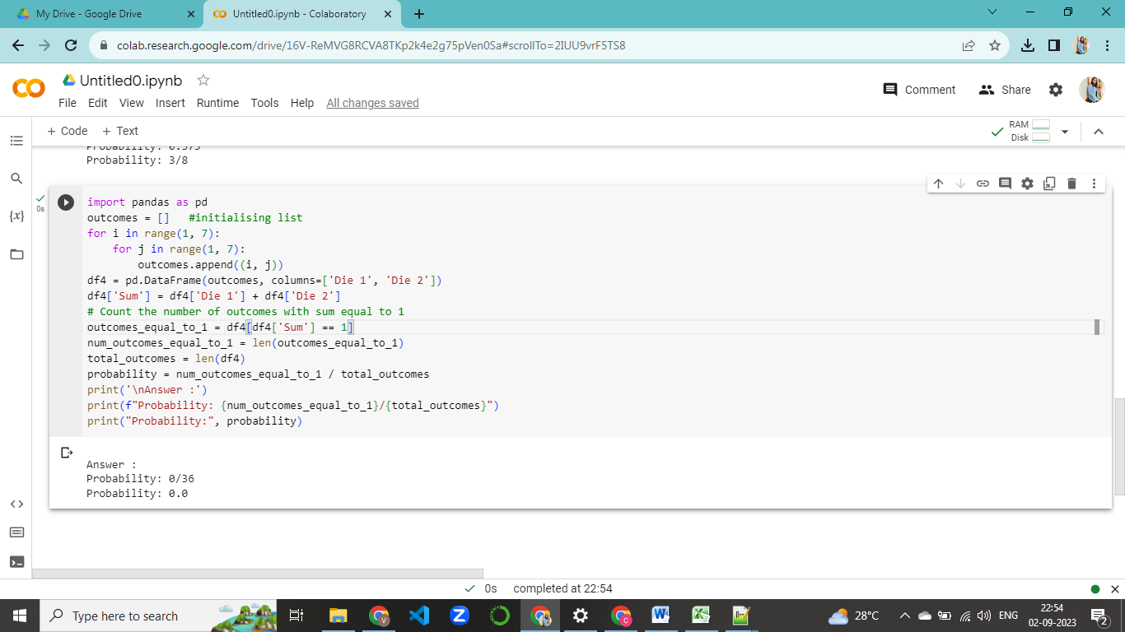

(b). Less than or equal to 4

Solution

If two dices were rolled, then total possible cases =36

Total Favourable cases (Having sum >=4) = 6 {(1,1),(1,2),(1,3),(2,1),(2,2),(3,1)}

probability is 6/36 or 0.166.

Python Code:

import pandas as pd

outcomes=[]

for i in range(1,7):

  for j in range(1,7):

    outcomes.append((i,j))

df4 = pd. DataFrame(outcomes,columns=['Die 1','Die 2'])

df4['Sum']=df4['Die 1'] + df4['Die 2']

outcomes_less_than_or_equal_to_4 = df4[(df4['Sum'] <=4)]

num_outcomes_less_than_or_equal_to_4 =len(outcomes_less_than_or_equal_to_4)

total_outcomes=len(df4)

probability = num_outcomes_less_than_or_equal_to_4/total_outcomes

print('\nAnswer :')

print(f"Probability :{num_outcomes_less_than_or_equal_to_4}/{total_outcomes}")

print("Probability :", probability)

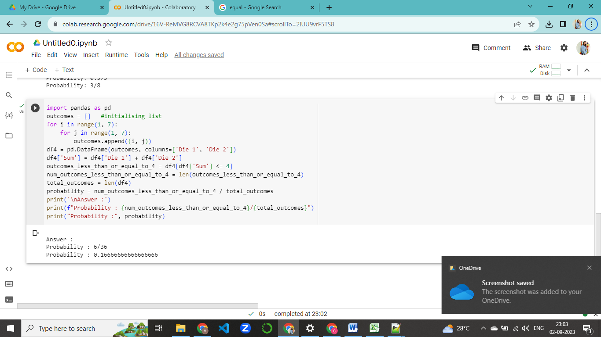

Output:

Answer :

Probability: 6/36

Probability: 0.16666666666666666

(c)Sum is divisible by 2 and 3

Solution

If two dices were rolled, then total possible cases =36

Total Favourable cases (Having Sum is divisible by 2 and 3) = 6 {(1,5), (2,4), (3,3), (4,2), (5,1), (6,6)}

probability is 6/36 or 0.166.

Python Code:

import pandas as pd

outcomes = []   #initialising list

for i in range(1, 7):

    for j in range(1, 7):

        outcomes.append((i, j))

df4 = pd.DataFrame(outcomes, columns=['Die 1', 'Die 2'])

df4['Sum'] = df4['Die 1'] + df4['Die 2']

outcomes_sum_is_divisible_by_2and3 = df4[(df4['Sum']%2 == 0) & (df4['Sum']%3 == 0)]

num_outcomes_sum_is_divisible_by_2and3 = len(outcomes_sum_is_divisible_by_2and3)

total_outcomes = len(df4)

probability = num_outcomes_sum_is_divisible_by_2and3 / total_outcomes

print('\nAnswer :')

print(f"Probability : {num_outcomes_sum_is_divisible_by_2and3}/{total_outcomes}")

print("Probability :", probability)

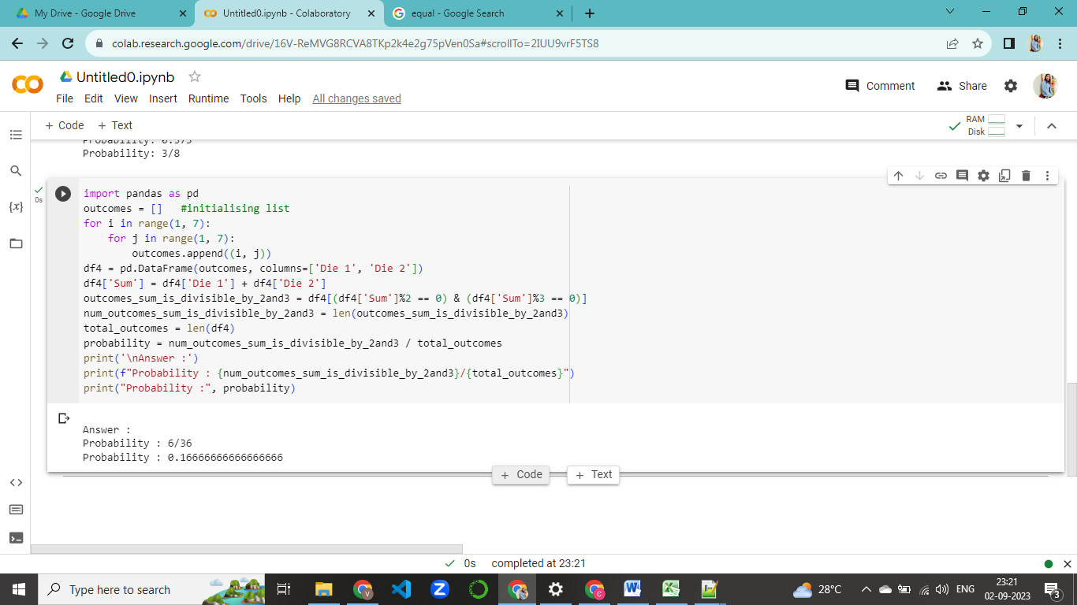

Q5) A bag contains 2 red, 3 green and 2 blue balls. Two balls are drawn at random. What is the probability that none of the balls drawn is blue?

Solution

Total number of balls in the bag = 2 (red) + 3 (green) + 2 (blue) = 7

The number of ways to choose 2 balls out of 7 (without replacement) is given by "7 choose 2," which is denoted as C(7, 2) and calculated as follows:

C(7, 2) = 7! / (2! * (7-2)!) = 7! / (2! * 5!) = (7 * 6) / (2 * 1) = 21

Now, let's consider the favorable outcomes, where we choose 2 balls such that none of them is blue. We can choose 2 balls from the 5 non-blue balls (2 red + 3 green). The number of ways to choose 2 balls out of 5 (without replacement) is given by "5 choose 2," which is denoted as C(5, 2) and calculated as follows:

C(5, 2) = 5! / (2! * (5-2)!) = 5! / (2! * 3!) = (5 * 4) / (2 * 1) = 10

So, the number of favorable outcomes is 10.

Now, the probability of not drawing any blue ball is given by:

Probability = (Number of favorable outcomes) / (Total number of outcomes)

Probability = 10 / 21 ≈ 0.4762

Therefore, the probability of not drawing any blue balls when two balls are drawn at random from the bag is approximately 0.4762 or 47.62%.

Python Code:

import pandas as pd

balls = ['red','red','green','green', 'green', 'blue', 'blue']  # Create a dataframe with the balls in the bag

df5 = pd.DataFrame(balls, columns=['Ball'])

num_non_blue_balls = df5[df5['Ball'] != 'blue'].shape[0] # Count the number of balls that are not blue

prob_non_blue = (num_non_blue_balls / len(df5)) * ((num_non_blue_balls - 1) / (len(df5) - 1))

print('\nAnswer :')

print("Probability:", prob_non_blue)

Output:

Answer :

Probability: 0.47619047619047616

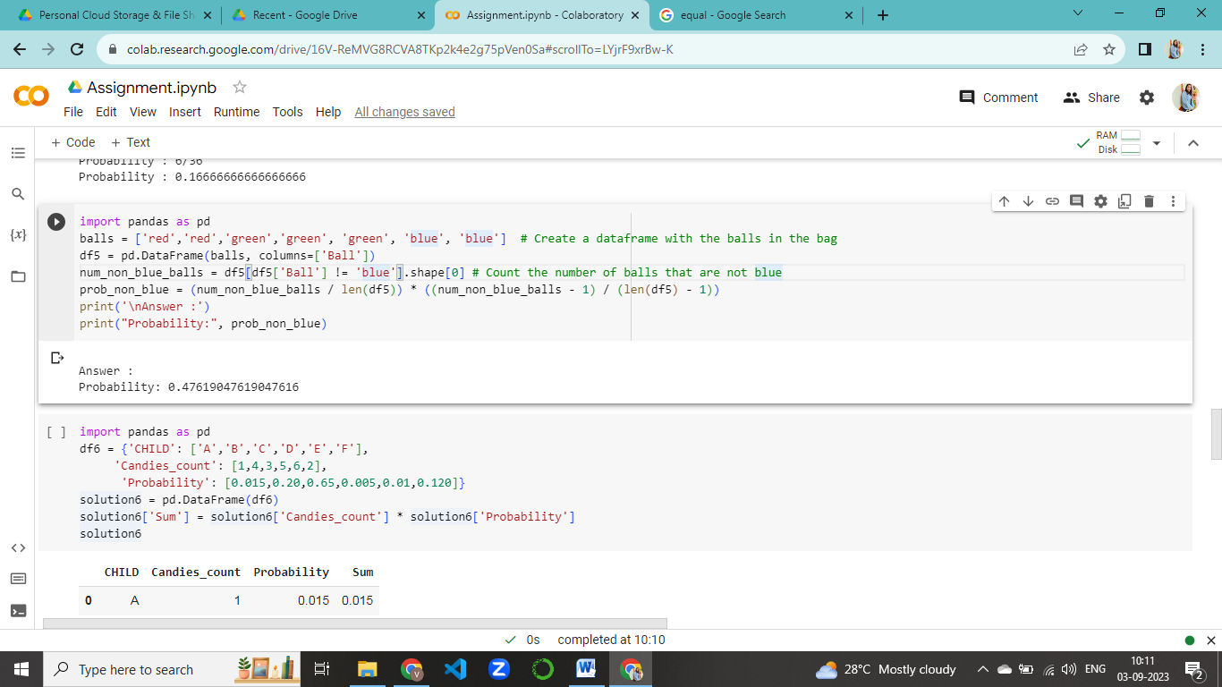

Q6) Calculate the Expected number of candies for a randomly selected child

Below are the probabilities of count of candies for children (ignoring the nature of the child-Generalized view)

|  |  |  |
| --- | --- | --- |
| CHILD | Candies count | Probability |
| A | 1 | 0.015 |
| B | 4 | 0.20 |
| C | 3 | 0.65 |
| D | 5 | 0.005 |
| E | 6 | 0.01 |
| F | 2 | 0.120 |

Child A – probability of having 1 candy = 0.015.

Child B – probability of having 4 candies = 0.20

Solution:

Expected number of candies for a randomly selected child

= (1 x 0.015 ) + (4 x 0.20) + (3 x 0.65) + (5 x 0.005) + (6 x 0.01) +( 2 x 0.12)

= 0.015 + 0.8 + 1.95 + 0.025 + 0.06 + 0.24

= 3.090

= 3.09

Python Code:

import pandas as pd

df6 = {'CHILD': ['A','B','C','D','E','F'],

     'Candies_count': [1,4,3,5,6,2],

      'Probability': [0.015,0.20,0.65,0.005,0.01,0.120]}

solution6 = pd.DataFrame(df6)

solution6['Sum'] = solution6['Candies_count'] * solution6['Probability']

solution6

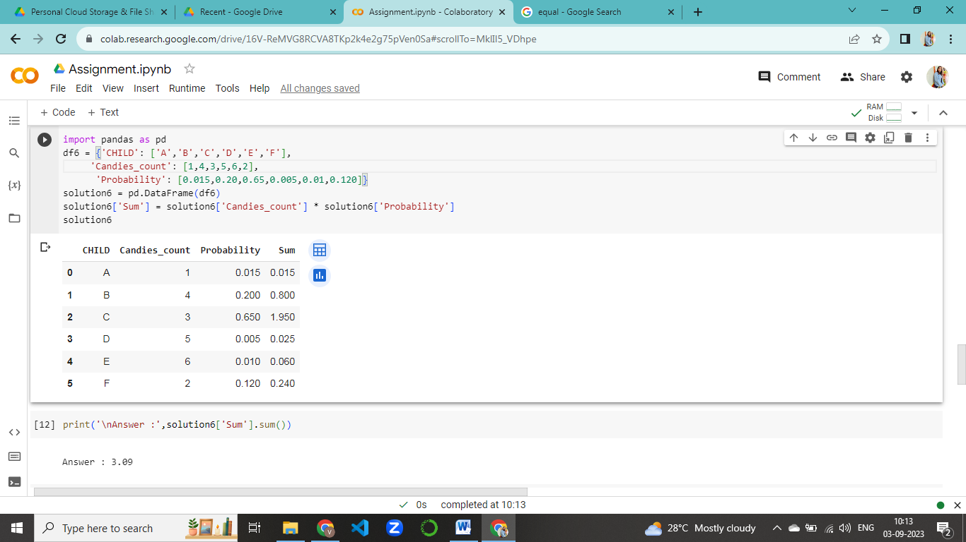

Output:

Answer : 3.09

Q7) Calculate Mean, Median, Mode, Variance, Standard Deviation, Range & comment about the values / draw inferences, for the given dataset

* For Points,Score,Weigh>

Find Mean, Median, Mode, Variance, Standard Deviation, and Range and also Comment about the values/ Draw some inferences.

**Use Q7.csv file**

Python Code:

import pandas as pd

df7 =pd.read_csv("Q7.csv")

df7.rename(columns = {'Unnamed: 0':'Model_Name'},inplace=True)

df7.describe()

# mean

C1_R1 = df7['Points'].mean()

C2_R1 = df7['Score'].mean()

C3_R1 = df7['Weigh'].mean()

# median

C1_R2 = df7['Points'].median()

C2_R2 = df7['Score'].median()

C3_R2 = df7['Weigh'].median()

# mode

C1_R3 = df7['Points'].mode()

C2_R3 = df7['Score'].mode()

C3_R3 = df7['Weigh'].mode()

# Standard deviation

C1_R4 = df7['Points'].std()

C2_R4 = df7['Score'].std()

C3_R4 = df7['Weigh'].std()

# range

C1_R5 = df7['Points'].max()-df7['Points'].min()

C2_R5 = df7['Score'].max()-df7['Score'].min()

C3_R5 = df7['Weigh'].max()-df7['Weigh'].min()

# Variance

C1_R6 = df7['Points'].var()

C2_R6 = df7['Score'].var()

C3_R6 = df7['Weigh'].var()

# Create dataframe with all Following Data type using Dict

df={'Value':['Mean', 'Median', 'Mode', 'Standard deviation', 'Range', 'Variance'],

    'Points':[C1_R1, C1_R2, C1_R3, C1_R4, C1_R5, C1_R6],

     'Score':[C2_R1, C2_R2, C2_R3, C2_R4, C1_R5, C1_R6],

     'Weigh':[C3_R1, C3_R2, C3_R3, C3_R4, C1_R5, C1_R6]}

solution6 = pd.DataFrame(df)

print('\nAnswer :',solution6)

Output:

Answer :

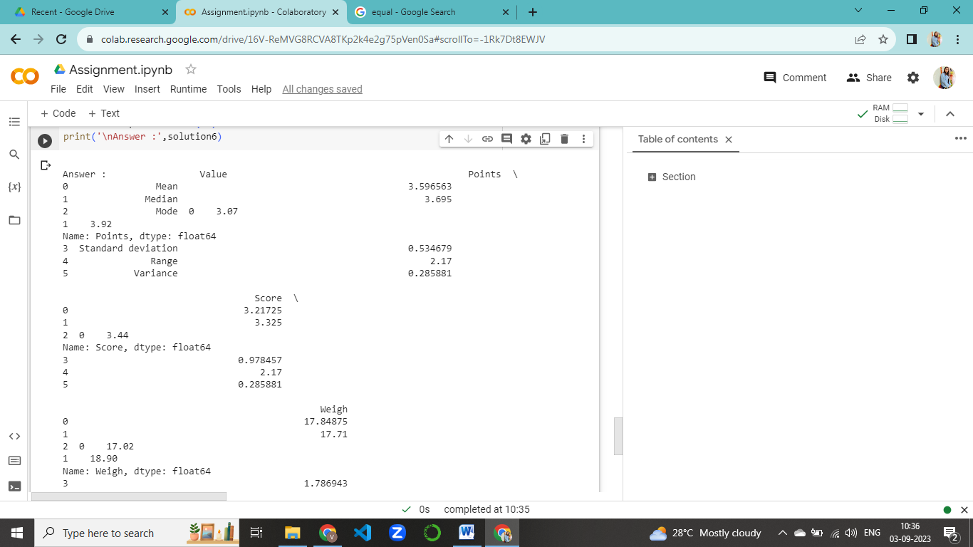

Q8) Calculate Expected Value for the problem below

1. The weights (X) of patients at a clinic (in pounds), are

108, 110, 123, 134, 135, 145, 167, 187, 199

Assume one of the patients is chosen at random. What is the Expected Value of the Weight of that patient?

Solution:

We have to find mean for the given data,

Python Code:

import numpy as np

patient_df=[108, 110, 123, 134, 135, 145, 167, 187, 199]

print(np.mean(patient_df))

Output:

Answer : 145.33333333333334

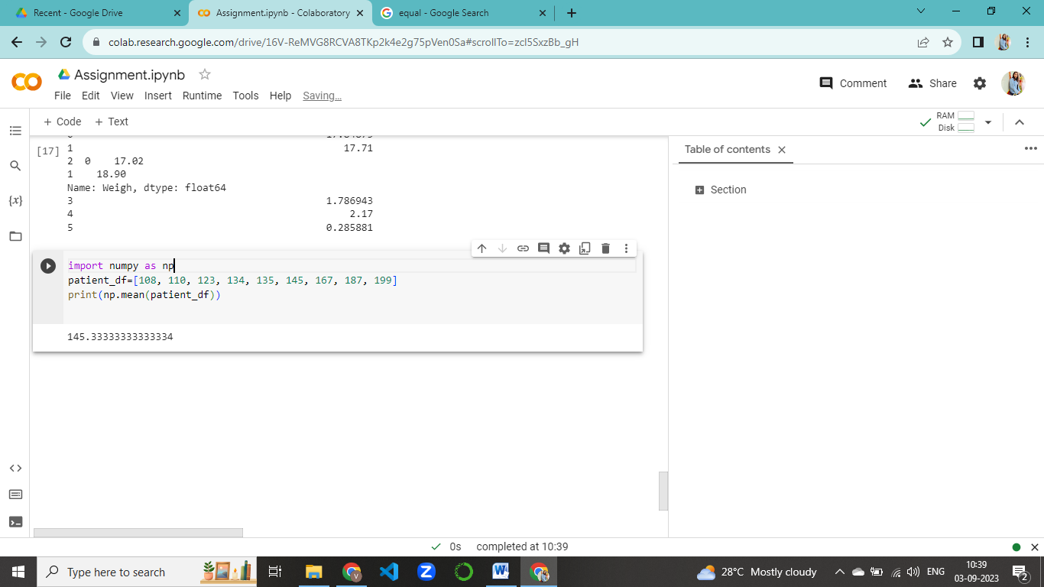

Expected Value of the Weight of that patient = 145.3333

Q9) Calculate Skewness, Kurtosis & draw inferences on the following data

1. Cars speed and distance

Use Q9_a.csv

1. SP and Weight(WT)

Use Q9_b.csv

a). data Cars speed and distance

Solution

Python Code:

df9_a = pd.read_csv('Q9_a.csv')

df9_a = df9_a.drop(['Index'], axis=1 )

df9_a.skew()

df9_a.kurtosis()

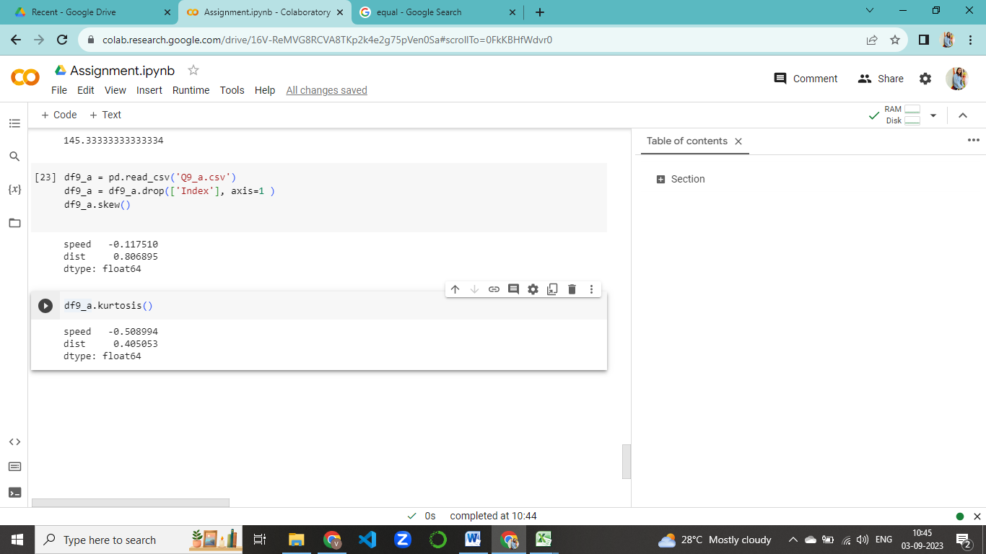

From the skewness of speed we can say that the data of speed is symmetric and from the distance we can say that the data is positively skewed.

Skewness = (speed) -0.117510, (dist) 0.806895

Kurtosis = (speed) -0.508994, (dist) 0.405053

b). SP and Weight(WT)

Solution

Python Code:

df9_b = pd.read_csv('Q9_b.csv')

df9_b = df9_b.drop(['Unnamed: 0'], axis=1 )

print("Skewness : " ,df9_b.skew())

print("Kurtosis : " ,df9_b.kurtosis())

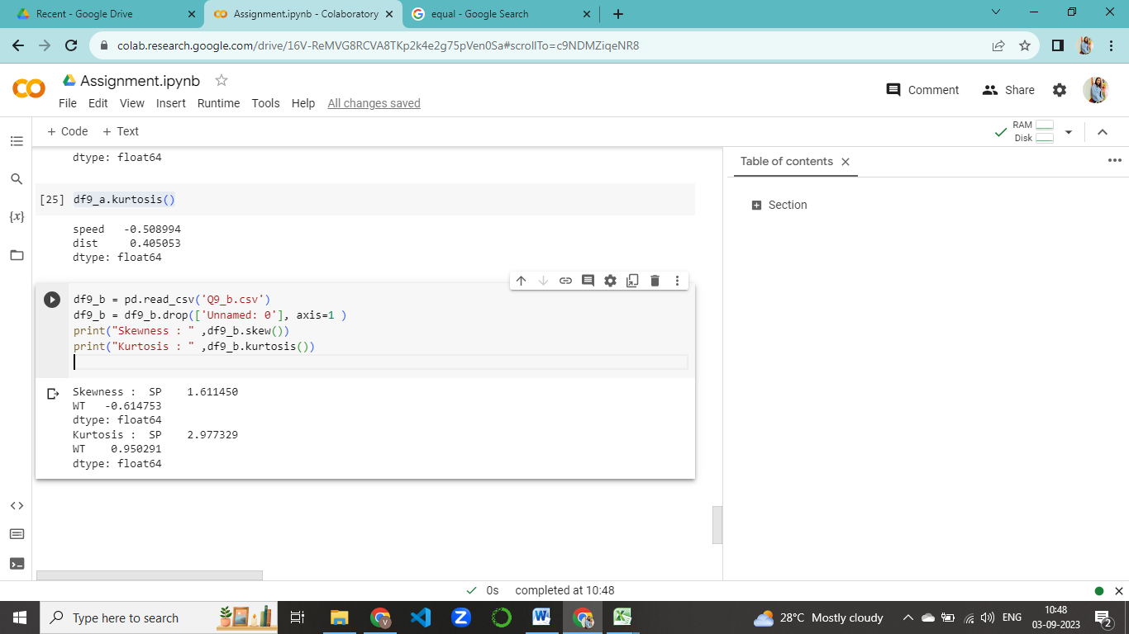

Answer :

From the skewness of SP we can say that the data of SP is positively skewed and from the skewness of weight we can say that the data is negatively skewed.

Skewness = (SP) 1.611450, (WT) -0.614753

Kurtosis = (SP) 2.977329, (WT) 0.950291

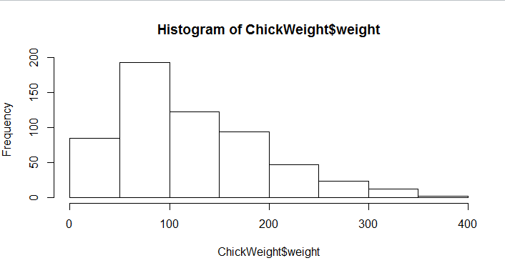**Q10) Draw inferences about the following boxplot & histogram**

Answer :

From the above histogram we can say that the data is Positively symmetric.

Answer :

From the above histogram we can say that the data is Positively

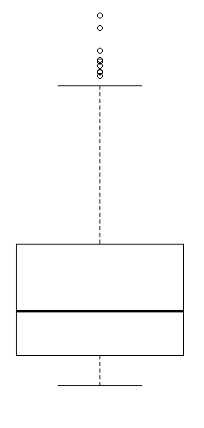 symmetric.

Answer :

This is a 6 point chart and it is going to give the information about:

Q1, Median value(Q2), Q3, lower limit, Upper Limit and outliers.

**Q11)** Suppose we want to estimate the average weight of an adult male in Mexico. We draw a random sample of 2,000 men from a population of 3,000,000 men and weigh them. We find that the average person in our sample weighs 200 pounds, and the standard deviation of the sample is 30 pounds. Calculate 94%,98%,96% confidence interval?

Solution :

Python Code:

import scipy.stats as stats

import numpy as np

# Specify the sample mean, standard deviation, and sample size

sample_mean = 200

sample_stddev = 30

sample_size = 2000

# Confidence levels

confidence_levels = [0.90, 0.94, 0.60]

# Calculate and display confidence intervals

for confidence_level in confidence_levels:

    alpha = 1 - confidence_level

    # Calculate the critical value (Z-score) for the given confidence level

    z_score = stats.norm.ppf(1 - alpha / 2)

    # Calculate the margin of error

    margin_of_error = z_score * (sample_stddev / np.sqrt(sample_size))

    # Calculate the confidence interval

    lower_bound = sample_mean - margin_of_error

    upper_bound = sample_mean + margin_of_error

    df11= (f"{confidence_level * 100}% Confidence Interval: ({lower_bound:.2f}, {upper_bound:.2f})")

    df11 = {'C.I.':['94%','96%','98%'],

      'Lower limit':[198.738325292158,198.62230334813333,198.62230334813333],

      'Upper Limit':[201.261674707842,201.37769665186667,201.56056159570022]}

df11 =pd.DataFrame(df11)

print('\nAnswer :')

df11

Output:

Answer :

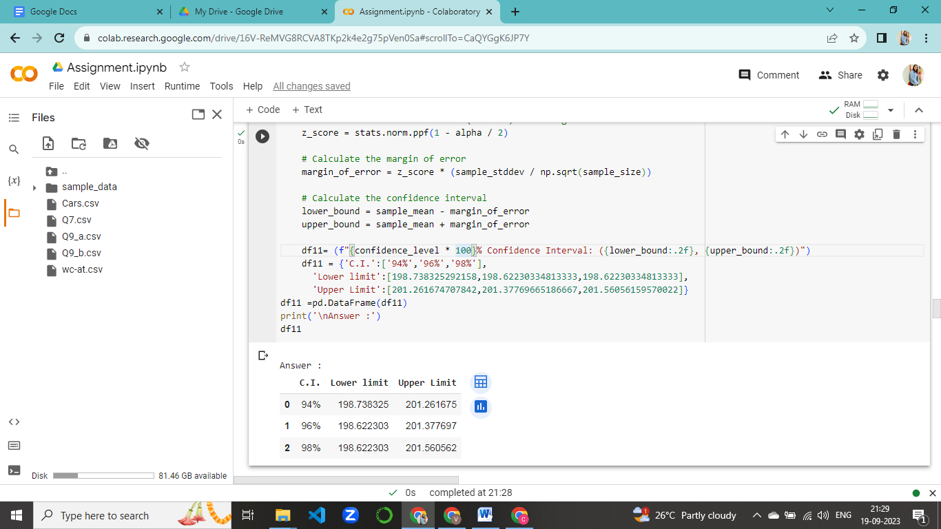

**Q12)** Below are the scores obtained by a student in tests

**34,36,36,38,38,39,39,40,40,41,41,41,41,42,42,45,49,56**

1. Find mean, median, variance, standard deviation.
2. What can we say about the student marks?
3. Find mean, median, variance, standard deviation.

***Solution***

Python Code:

import pandas as pd

import numpy as np

x=[34,36,36,38,38,39,39,40,40,41,41,41,41,42,42,45,49,56]

print("Mean - ",np.mean(x))

print("Median - ",np.median(x))

print("Variance -",np.var(x))

print("Standard -",np.std(x))

df12 ={'A':['Mean','Median','Variance','Standard Deviation'],

     'B': [41,40.5,24.1111,4.9103]}

df12= pd.DataFrame(df12)

print('\nAnswer :')

df12

Answer :



2.What can we say about the student marks?

Student scores 41 marks as an average.

Q13) What is the nature of skewness when mean, median of data are equal?

Answer :

The nature of skewness is perfectly symmetric that is it is zero skewed. When the mean and median of data are equal, the skewness is close to zero, indicating a symmetric distribution without a significant tail on either side

Q14) What is the nature of skewness when mean > median ?

Answer :

The nature of skewness is positively skewed.

When the mean is greater than the median, it suggests a positive skewness, indicating that the distribution has a longer tail on the right side.

Q15) What is the nature of skewness when median > mean?

Answer :

The nature of skewness is negatively skewed.

When the median is greater than the mean, it suggests a negative skewness, indicating that the distribution has a longer tail on the left side.

Q16) What does positive kurtosis value indicates for a data ?

Answer :

Positive tail indicates that we have heavy tails that is lot of data lies in tails.

A positive kurtosis value indicates that a data set has heavier tails and a more peaked central region compared to a normal distribution. It suggests the presence of outliers or extreme values, resulting in a distribution that is more concentrated around the mean with fatter tails.

Q17) What does negative kurtosis value indicates for a data?

Answer :

Negetive tail indicates that we have light tails that is little data lies in the tails.

A negative kurtosis value indicates that a data set has lighter tails and a flatter central region compared to a normal distribution. It suggests a lack of outliers or

extreme values, resulting in a distribution that is less concentrated around the mean with thinner tails.

Q18) Answer the below questions using the below boxplot visualization.

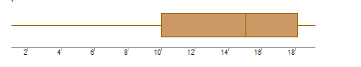

a). What can we say about the distribution of the data?

Answer :

We can say that there is a big difference between upper quartile and upper extreme compared to the lower quartile and lower extreme.

b). What is nature of skewness of the data?

Answer :

The nature of skewness is negatively skewed.

or

Left Skewed

c). What will be the IQR of the data (approximately)?

Answer :

IQR = Q3-Q1

IQR = 18-10

IQR = 8

Q19) Comment on the below Boxplot visualizations?

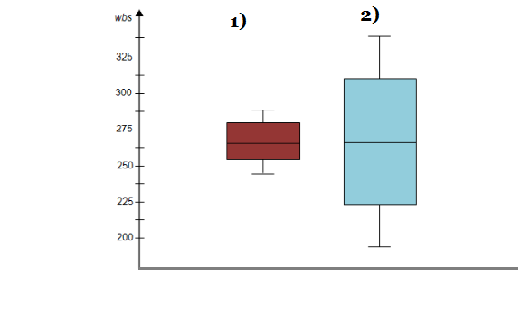

Draw an Inference from the distribution of data for Boxplot 1 with respect Boxplot 2.

Answer :

Medium is same for both graph, there is difference between upper limit and lower limit (IQR1-IQR2) and there is no outliers in both the boxplot.

Q 20) Calculate probability from the given dataset for the below cases

Data _set: Cars.csv

Calculate the probability of MPG of Cars for the below cases.

MPG <- Cars$MPG

* 1. P(MPG>38)
  2. P(MPG<40)

c. P (20<MPG<50)

Solution :

Python Code:

import pandas as pd

import numpy as np

df20 = pd.read_csv('Cars.csv')

average=np.mean(df20['MPG'])

std=np.std(df20['MPG'])

1-(stats.norm.cdf(38, loc=average, scale=std))

At P(MPG>38)



import pandas as pd

import numpy as np

df20 = pd.read_csv('Cars.csv')

average=np.mean(df20['MPG'])

std=np.std(df20['MPG'])

stats.norm.cdf(40, loc=average, scale=std)

At P(MPG<40)

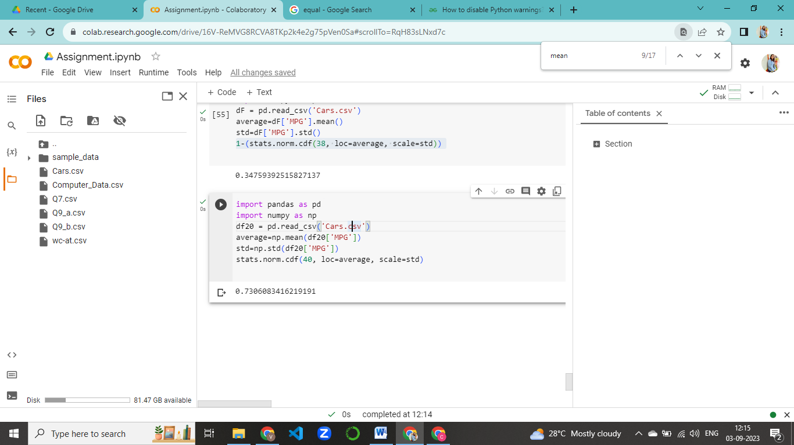

import pandas as pd

import numpy as np

df20 = pd.read_csv('Cars.csv')

average=np.mean(df20['MPG'])

std=np.std(df20['MPG'])

stats.norm.cdf(50, loc=average, scale=std)- stats.norm.cdf(20, loc=average,scale=std)

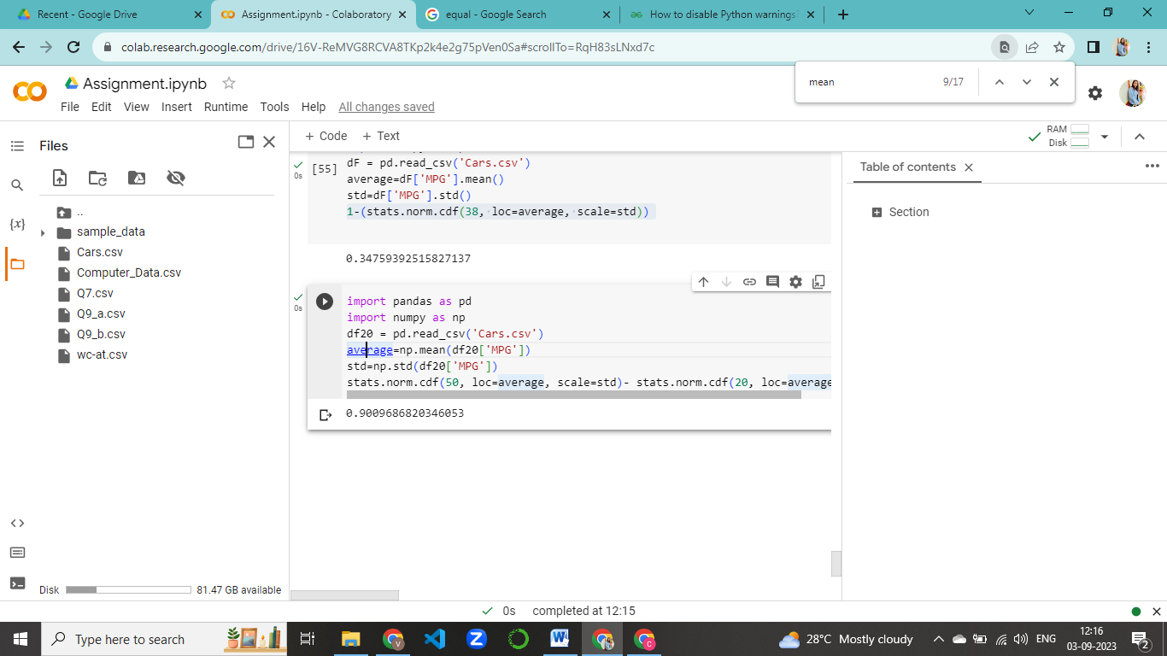

df20 = {'A':['P(MPG>38)','P(MPG<40)','P(20<MPG<50)'],

      'B':[0.3475939251582705,0.7293498762151616,0.8988689169682046]}

df_20 = pd.DataFrame(df20)

df_20

Output:



Q 21) Check whether the data follows normal distribution

1. Check whether the MPG of Cars follows Normal Distribution

Dataset: Cars.csv

1. Check Whether the Adipose Tissue (AT) and Waist Circumference(Waist) from wc-at data set follows Normal Distribution

Dataset: wc-at.csv

1. Check whether the MPG of Cars follows Normal Distribution

Python Code:

import pandas as pd

import matplotlib.pyplot as plt

import seaborn as sns

df21= pd.read_csv("Cars.csv")

sns.distplot(df21['MPG'])

plt.title('Histogram To Check Normality')

plt.show()

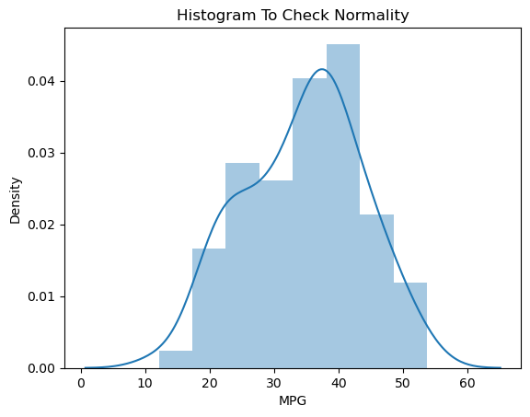

From the plot we can say that the data follows normal distribution.

1. Check Whether the Adipose Tissue (AT) and Waist Circumference(Waist) from wc-at data set follows Normal Distribution.

Python Code:

import pandas as pd

import matplotlib.pyplot as plt

import seaborn as sns

df21= pd.read_csv("wc-at.csv")

sns.distplot(df21['Waist'])

plt.title('Histogram To Check Normality')

plt.show()

sns.distplot(df21['AT'])

plt.title('Histogram To Check Normality')

plt.show()

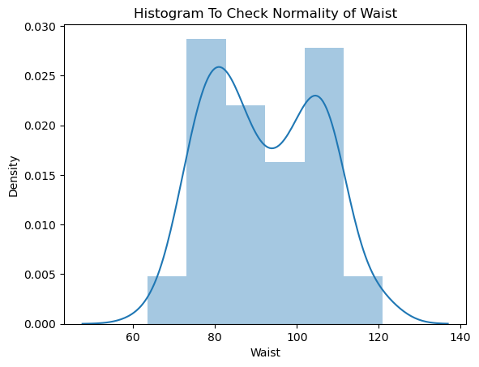

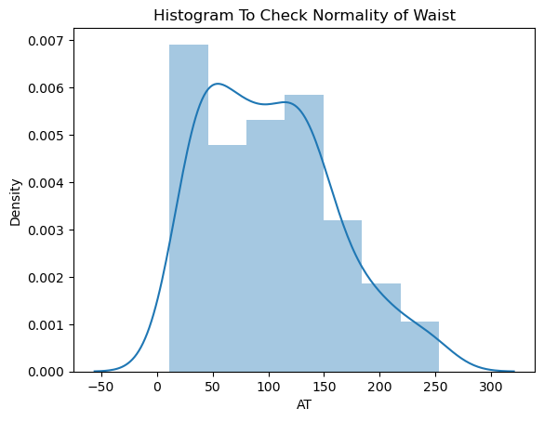

From the above plots we can say that, the data is normally distributed for ‘Waist’ and data is positively skewed for ‘AT’.

Q 22) Calculate the Z scores of 90% confidence interval,94% confidence interval, 60% confidence interval

Python Code:

import scipy.stats as stats

# Confidence levels

confidence_levels = [0.90, 0.94, 0.60]

# Calculate and display Z-scores

for confidence_level in confidence_levels:

    alpha = 1 - confidence_level

    # Calculate Z-score for the upper tail (right tail)

    z_score = stats.norm.ppf(1 - alpha / 2)

    print(f"Z-score for a {confidence_level * 100}% confidence interval: {z_score:.3f}")

Answer :

Z scores (two tailed) for ,

90% confidence interval = 1.645

94% confidence interval = 1.881

60% confidence interval = 0.842

Q 23) Calculate the t scores of 95% confidence interval, 96% confidence interval, 99% confidence interval for sample size of 25

Python Code:

import scipy.stats as stats

# Sample

sample_size = 25

degrees_of_freedom = sample_size - 1

# Confidence levels

confidence_levels = [0.95, 0.96, 0.99]

# Calculate and display critical t-values

for confidence_level in confidence_levels:

    alpha = 1 - confidence_level

    critical_t_value = stats.t.ppf(1 - alpha / 2, degrees_of_freedom)

    print(f"Critical t-value for a {confidence_level * 100}% confidence interval: {critical_t_value:.3f}")

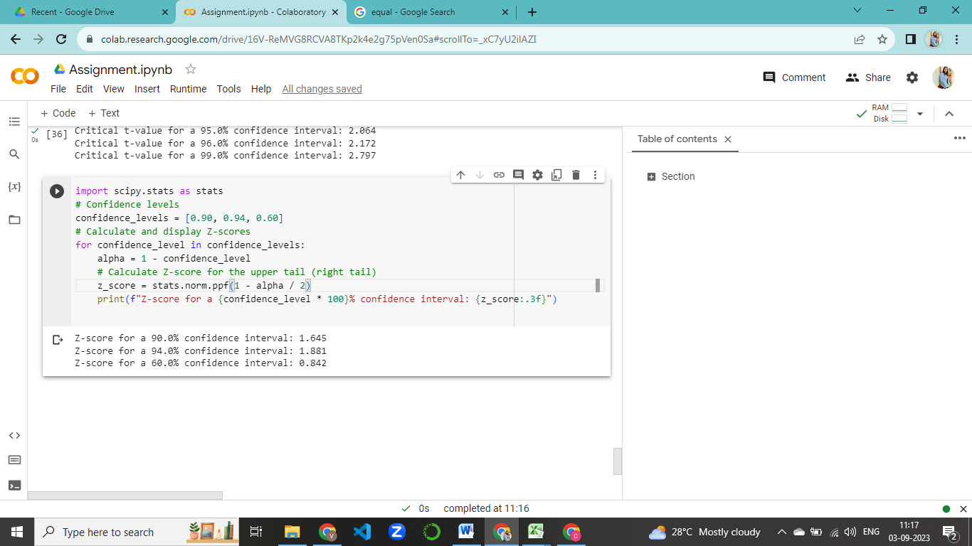

Answer :

t scores for ,

95% confidence interval = 2.0638985616280205

96% confidence interval = 2.1715446760080677

99% confidence interval = 2.796939504772804

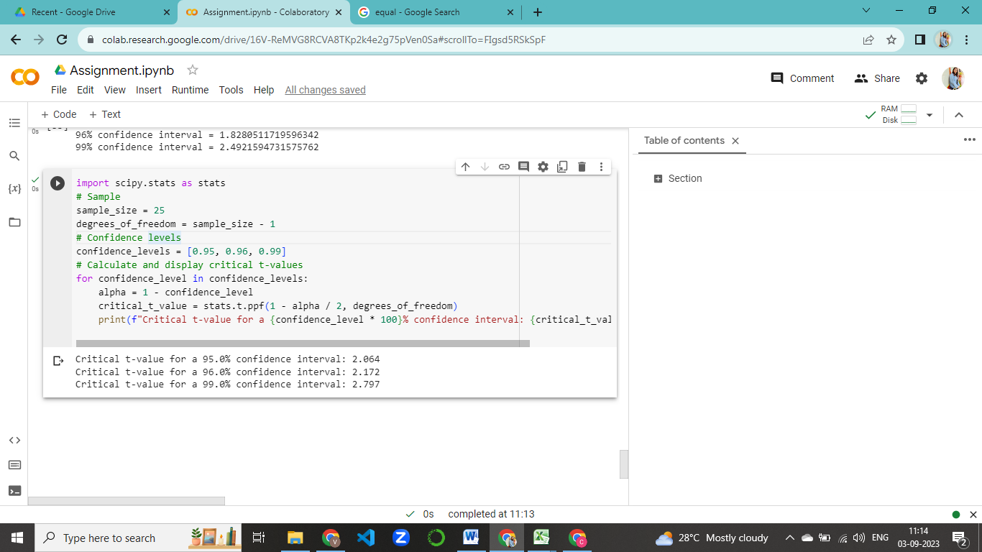

Q 24**)** A Government company claims that an average light bulb lasts 270 days. A researcher randomly selects 18 bulbs for testing. The sampled bulbs last an average of 260 days, with a standard deviation of 90 days. If the CEO's claim were true, what is the probability that 18 randomly selected bulbs would have an average life of no more than 260 days

Hint:

rcode 🡪 pt(tscore,df)

df 🡪 degrees of freedom

Python Code:

from scipy.stats import t

# Given data

sample_mean = 260

population_mean = 270

sample_std = 90

sample_size = 18

# Degrees of freedom

df24 = sample_size - 1

# Calculate the t-score

t_score = (sample_mean - population_mean) / (sample_std / np.sqrt(sample_size))

# Calculate the probability (p-value) using the cumulative distribution function (CDF)

p_value = t.cdf(t_score, df24)

# Probability of having an average life of no more than 260 days

probability = p_value

print("The probability is:", probability)

